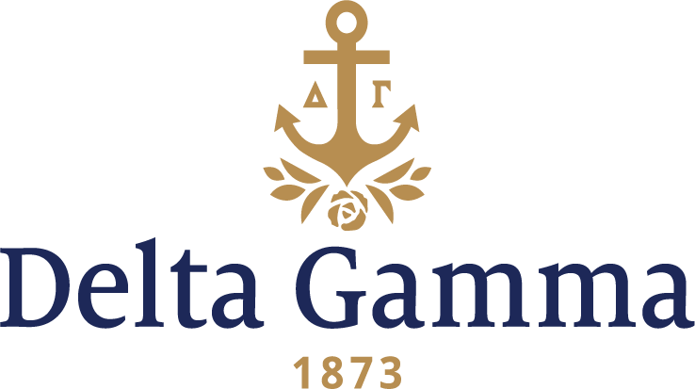
Beta Rho-George Washington
Fast Facts:
- Installation date: October 6, 1945
- Closure date: June 6, 1982
- Re-establishment date: April 1, 1990
- Closure date: September 30, 2015
- Location: Washington, DC
- Region: 2

History:
Columbian College's first location became known as "College Hill." This 46 ½ acre tract of land extended north of Boundary Street (now Florida Avenue) between 14th and 15th Streets. In 1904, Columbian University became The George Washington University by an Act of Congress.

Delta Gamma first expressed interest in establishing at George Washington with the encouragement of Helen Dyer, Psi (III)-Goucher. The University responded favorably to the idea, as did the Washington DC alumnae. In the fall of 1941, George Washington University invited Delta Gamma to establish a chapter on campus. However, after the bombing of Pearl Harbor in 1942, Delta Gamma declined the invitation to colonize.

In 1943, a group of women on campus established the group Themian. By October of the next year, the group decided that it wanted to affiliate with a national organization. On February 12, 1945, Themian received permission from President Marvin to petition a national organization. Thirteen women of Themian submitted a written petition to Delta Gamma on April 10, 1945. Shortly thereafter, the President of the university confirmed that a Delta Gamma chapter would be welcome on campus. On May 23, 1945, eighteen women pledged the Beta Rho chapter.

The chapter was officially installed in October of 1945. The festivities began on Friday, October 5 with a Fraternity Round Table held in the chapter room at George Washington University. On Saturday evening, the women of Beta Rho were initiated. On October 7, Beta Rho held its first chapter meeting.

Beta Rho and Beta Sigma held a joint Installation celebration, as Beta Sigma was installed the weekend following Beta Rho. The joint banquet was held on October 13 in the evening.

The Beta Rho chapter began as a strong chapter. The women were committed to upholding the ideals of our founders and were dedicated to spreading Delta Gamma at George Washington. However, there were forces outside of the chapter’s control that influenced their success.

By the early 1980’s, the chapter was struggling with recruiting women and visibility on campus. At the time, Beta Rho was one only two Panhellenic organizations on campus, and their relationship with the other organization was strained. Furthermore, the Panhellenic community was not supported by the University. During a visit conducted in January of 1983, great concern was expressed about these issues plaguing Beta Rho. Most notably, the relationship with the other Panhellenic chapter was particularly destructive during recruitment, during which members of this organization would severely criticize the Beta Rho’s during rounds. This significantly impacted Beta Rho’s ability to recruit, which was further exacerbated by the University’s lack of support. These concerns, along with the visibility issues and some internal leadership concerns, appeared too great to overcome.

On March 24, 1982, Council voted unanimously to suspend Beta Rho’s charter, citing chapter size and general conditions of the chapter being below Fraternity standards as their reasoning. This decision initiated the 60-day period during which Council would entertain letters from collegians and alumnae about this decision, and the culmination of which would come Council’s final decision. Council finalized their decision on June 6, 1982.

Following the closure of the chapter, the women of Beta Rho renamed themselves Alpha Omega and operated as a local sorority.

In 1985, news of a revival in the interest of Greek life on George Washington’s campus reach Executive Offices. During this year, three Panhellenic chapters established on campus, followed by a fourth in 1987, bringing the total number of chapters on campus to five. With all this expansion, the members of Alpha Omega contacted the University in order to gain permission to petition Delta Gamma for their charter. By 1987, the Fraternity began to consider reopening the Beta Rho chapter but were hesitant to consider doing so until at least the spring of 1989 due to a full expansion schedule and the recent establishment of a Sigma Kappa chapter at George Washington.

In February of 1989, the president of the Panhellenic Council and the Greek Affairs Coordinator sent a letter to Executive Offices about reopening the Beta Rho chapter at the urging of Alpha Omega. On April 30, 1989, Alpha Omega officially petitioned Delta Gamma to be reinstated as the Beta Rho chapter. The Fraternity responded favorably on May 2, and on the weekend of October 18-21, Beta Rho recolonized at George Washington.

The Installation festivities were held the weekend of March 30- April 1, 1990. On Saturday, March 31, the women of Alpha Omega experienced the Inspiration ceremony. Th next day, they were initiated at the Sheraton Crystal City Hotel, followed by an Installation Luncheon that afternoon.

Their early years as a reinstated chapter were very promising. Beta Rho was recognized six times from 1992-1997 as a Foundation Top Ten Participants in Sight Conservation and Aid to the Blind Projects. Similarly, the chapter received the Patricia Peterson Danielson Award six times in a 15-year period. In 2012, they were recognized at Convention with the Outstanding House Corporation Award as a Chapter with a University managed house.

Their Foundation activities include bowling with visually impaired from the Columbia Lighthouse, a fund-raising bowl-a-thon, Anchor Splash® (first held in November 1991), making coloring books for blind children, helping the blind wrap presents at Christmas, and reading to the blind. The Chapter also worked on the project Vistech with the Northern Virginia Alumnae chapter.

Despite these positive accolades and involvement, the chapter was placed on probation in December of 2014 for failure to comply with Fraternity policy and behavior unbecoming of Delta Gamma standards. The chapter officially closed effective September 30, 2015.

Since joining the George Washington campus in 1945, Beta Rho has occupied various on-campus chapter houses designated for Greek use.

